Case 17-AM,C-Taino–Zemi-Frigate Bird-Mano-Vesicular Basalt
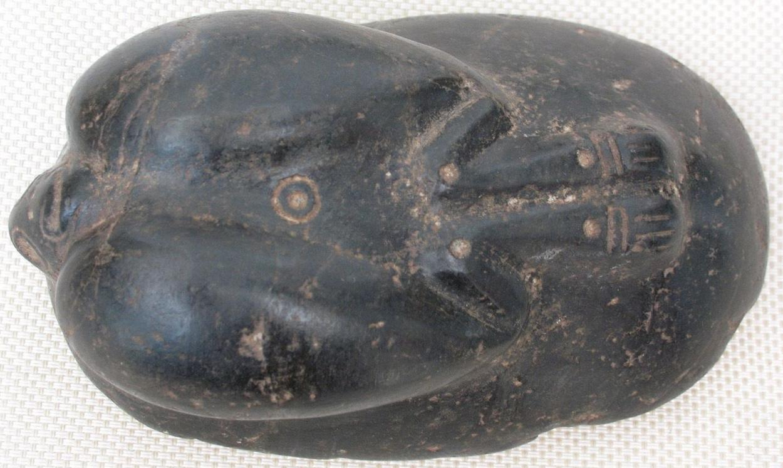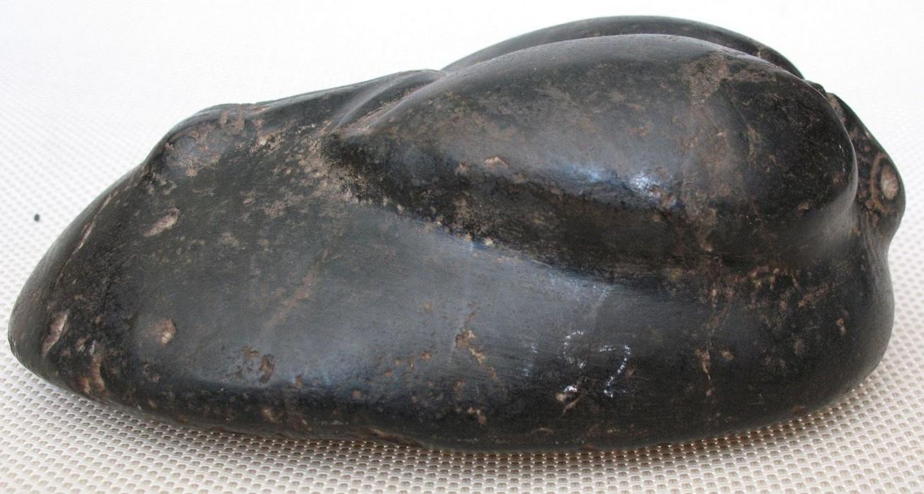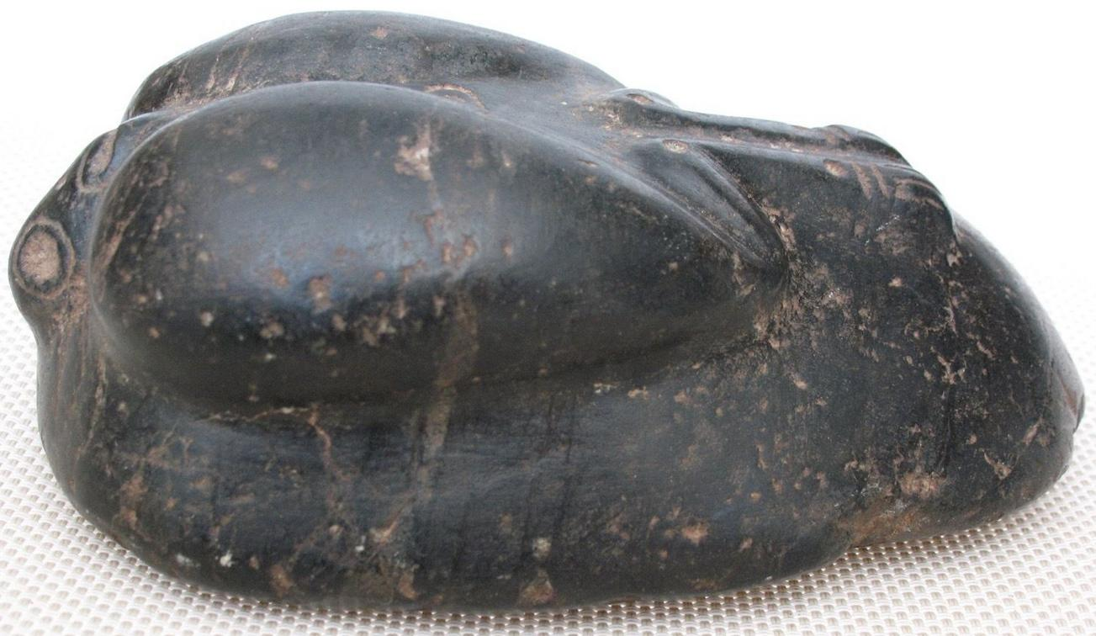
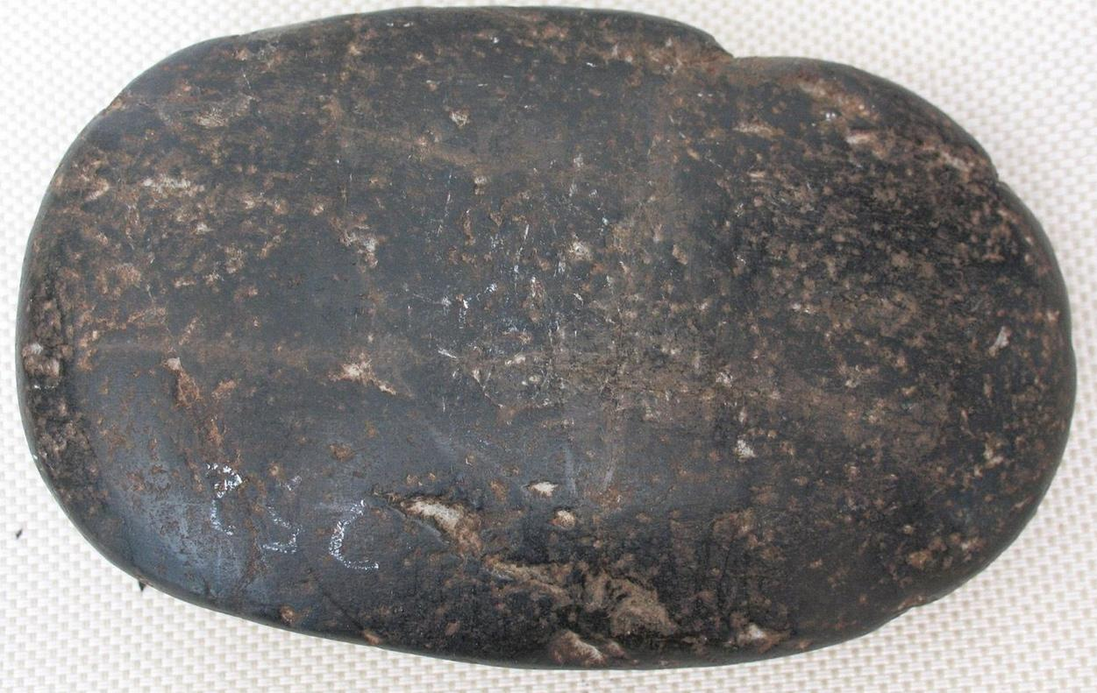
Case No.: 17
Accession Number:
Formal Label:
AM,C-Taino–Zemi-Frigate Bird-Mano-Vesicular Basalt
Display Description:
Great aerial agility enables frigatebirds to pirate the food that other birds have swallowed until it is regurgitated and then the frigatebird catches it in mid-air. This scavenging behavior has earned them the title of 'Man-o'-War Bird'. Since frigatebirds lack lanolin on their plumage they neither are not waterproof as are other marine fowl nor do they have webbed feet. Therefore, they are rarely seen on water.
LC Classification:
Date or Time Horizon:
Geographical Area: Map:

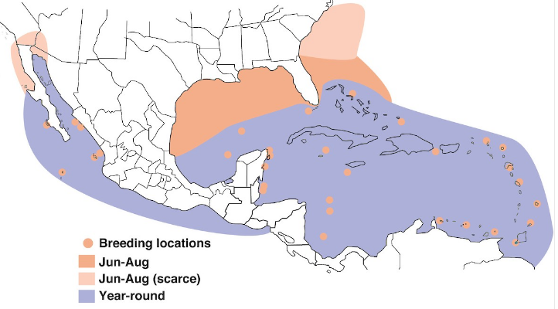
Figure 3. Magnificent Frigatebird: breeding distribution, US and Middle America. After https://birdsna.org/Species-Account/bna/species/magfri/introduction

GPS Coordinates:
Cultural Affiliation:
Medium:
Dimensions:
Weight:
Provenance:
Condition:
Discussion:
References:

Item condition:
--not specified
Ended:
Sep 30, 2015 , 5:21PM
Winning bid:
US $250.00
[ 1 bid ]
Join eBay Bucks and earn % back on this item. See conditionsfor eBay Bucks - opens in a new window or tab
Shipping:
$15.00 E

